[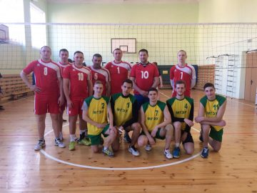](http://www.iseu.bsu.by/wp-content/uploads/2019/04/IMG_9061.jpg)